NOVEMBER
written by Maurice Sendak

In November's gusty gale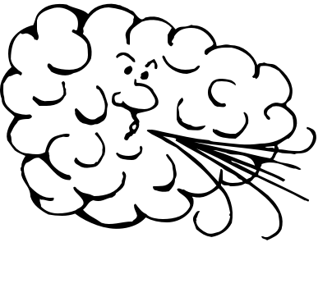

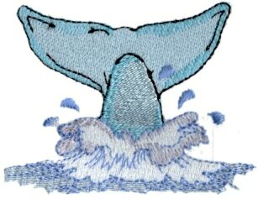I will flop my flippy tail

and spout hot soup I’ll be a whale!

Spouting once, spouting twice

Spouting chicken soup with rice.

