**Spiders**

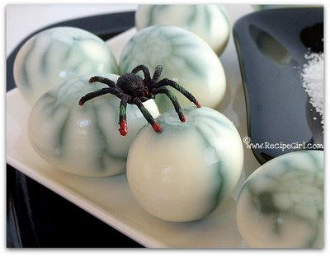 Spiderlings hatch from eggs,

Each one has 8 tiny legs. 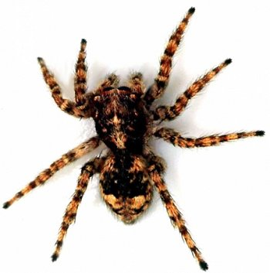

 Spiders have more eyes than you,

Most have 8 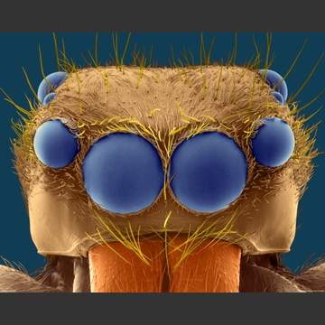 and you have 2. 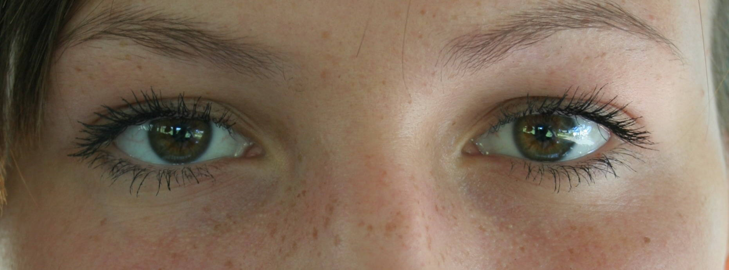

A spider has 2 body parts, 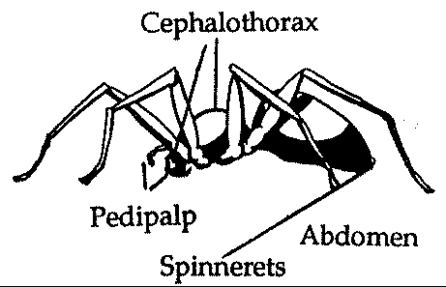

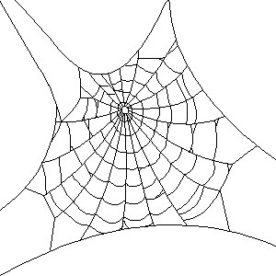 Across its web it quickly darts.

From a spiders spinnerets

Silky spider silk jets. 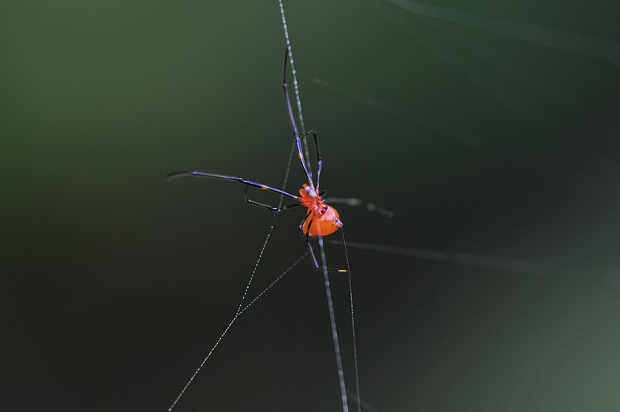

Spiders feel the frantic tugs

From their favorite food …BUGS! 